Stock Return Prediction using Supervised Machine Learning

1. Introduction
This project predicts the next-week return of Microsoft (MSFT) with five supervised-learning frameworks and finds that only a small edge over a naive baseline is possible: the best model, fastai, cuts test RMSE from 0.0374 to 0.0367 and explains 3.5% of the variance.
Predicting stock prices is one of the hardest problems in finance. Prices react to news, the economy and investor behaviour, and in an efficient market most of the information that could predict a move is already in today's price. Machine learning can still look for small, repeatable patterns in historical data that simple rules miss.
Three families of inputs are commonly used for stock prediction:
- Correlated assets: other stocks, currencies, indices and commodities that move with the company's share price.
- Technical indicators: signals built from price history, such as moving averages and momentum.
- Fundamental analysis: company metrics such as ROE and P/E from financial reports, plus news.
This case study uses the first family, together with MSFT's own past returns.

Objectives
- Collect 16 years of daily market data from Yahoo Finance and prepare it for supervised learning.
- Explore the data to understand return distributions, relationships between assets and stationarity.
- Build the same regression model in five frameworks: XGBoost, Keras, PyTorch with fastai, PyTorch with TabNet and PyTorch with Lightning Flash.
- Calculate each model's expected return for the coming week.
- Compare the frameworks on simplicity, transparency and efficacy, and on RMSE, MAE and R².
The weekly return is predicted rather than the price because prices trend upward over time (they are non-stationary), while returns are stable in scale and directly meaningful to an investor.

2. Methodology
All five models are trained on the same features, the same chronological split and the same evaluation code, so differences in results come from the frameworks alone.

2.1 Data
Daily closing prices for eight series were downloaded from Yahoo Finance with the yfinance library, from 4 January 2010 to 2 November 2026 (4,234 US trading days). Prices are adjusted for splits and dividends.
Group | Asset | Yahoo ticker
Target stock | Microsoft | MSFT
Stocks | IBM, Alphabet | IBM, GOOGL
Currencies | US dollar / Japanese yen, British pound / US dollar | JPY=X, GBPUSD=X
Indices | S&P 500, Dow Jones Industrial Average, CBOE Volatility Index | ^GSPC, ^DJI, ^VIX
Currency markets trade on some US holidays and close on others, so 6 days had no exchange rate. These were filled with the previous day's value (forward fill). Yahoo Finance was used for every series, including the indices and currencies that the case study takes from FRED, so that all data comes from one source on one calendar.

2.2 Target and features
All returns are log returns, where P is the closing price and h the number of trading days:
r_{t,h} = \ln P_t - \ln P_{t-h}
- Target (Y): MSFT's log return over the next 5 trading days, r(t+5, 5). Shifting it forward means each row predicts the future, never the past.
- Correlated-asset features (7): the past 5-day log return of IBM, GOOGL, USD/JPY, GBP/USD, S&P 500, Dow Jones and VIX.
- Lagged MSFT features (4): MSFT's own past log return over 5, 15, 30 and 60 trading days.
One row is kept every 5 trading days so that the weekly windows do not overlap, and rows with missing values (the first 60 days) are dropped. This leaves 834 weekly observations with 11 features.

2.3 Train/test split
The data is split by time, never shuffled, so the models are always tested on a future they have not seen. Shuffling would leak future information into training (look-ahead bias) and make results look better than they are.
Set | Period | Weeks
Training | 31 Mar 2010 – 23 Jun 2023 | 667 (80%)
Test | 30 Jun 2023 – 21 Oct 2026 | 167 (20%)
The neural networks hold out the last 20% of the training period as a validation set for early stopping. XGBoost is tuned with 5-fold time-series cross-validation inside the training period.

2.4 Models
Framework | Model | Main settings
XGBoost | Gradient-boosted decision trees | Grid search over trees (100, 300), depth (2, 3, 5) and learning rate (0.01, 0.05); subsample 0.8; best: 100 trees, depth 2, rate 0.01
Keras (PyTorch backend) | Multi-layer perceptron | Dense 32 → dropout 0.2 → Dense 16 → output; Adam, learning rate 0.001; up to 300 epochs, early stopping after 20
PyTorch + fastai | tabular_learner neural network | Layers 64 and 32; one-cycle training for up to 50 epochs at 0.001; early stopping after 10; best epoch kept
PyTorch + TabNet | Attention-based network for tables | 3 decision steps, width 8; up to 200 epochs, early stopping after 20; batch 128
PyTorch + Lightning Flash | TabularRegressor, category-embedding backbone | Learning rate 0.001; up to 50 epochs, early stopping after 10
Features are standardised with the training set's mean and standard deviation for the networks that need it. Weekly returns are tiny numbers (standard deviation about 0.034), which stalled training in the default settings of Keras, fastai and Lightning Flash. These three are therefore trained on returns in percent (×100) and their predictions converted back.
Lightning Flash is no longer maintained and does not install on current Python, so it runs in a separate Python 3.10 environment with pinned versions (PyTorch 1.13, PyTorch Lightning 1.9).

2.5 Evaluation
Each model is scored on the 167 test weeks with four metrics:
- RMSE (root mean squared error): typical error size, penalising large misses most.
- MAE (mean absolute error): average error size.
- R²: share of the variance in returns the model explains; 0 means no better than predicting the mean.
- Directional accuracy: share of weeks where the predicted sign (up or down) is correct.
Two baselines set the bar. The mean baseline always predicts the training-period average weekly return, and gives the baseline RMSE and MAE. The "always up" baseline always predicts a rise, and gives the baseline directional accuracy. A model only adds value if it beats these.
The expected return for the coming week is each model's prediction for the most recent feature row (2 November 2026), whose outcome is not yet known.

3. Exploratory Data Analysis
The EDA shows weekly returns that are stationary, fat-tailed and strongly tied to the market in the same week, which sets clear limits on what a model can predict about next week.

3.1 Data quality
The raw table has 4,234 trading days and 8 series. The only missing values are 6 days each for USD/JPY and GBP/USD, caused by currency-market holidays that differ from US stock-market holidays. They were forward-filled, so each gap takes the previous day's rate.

3.2 Price history
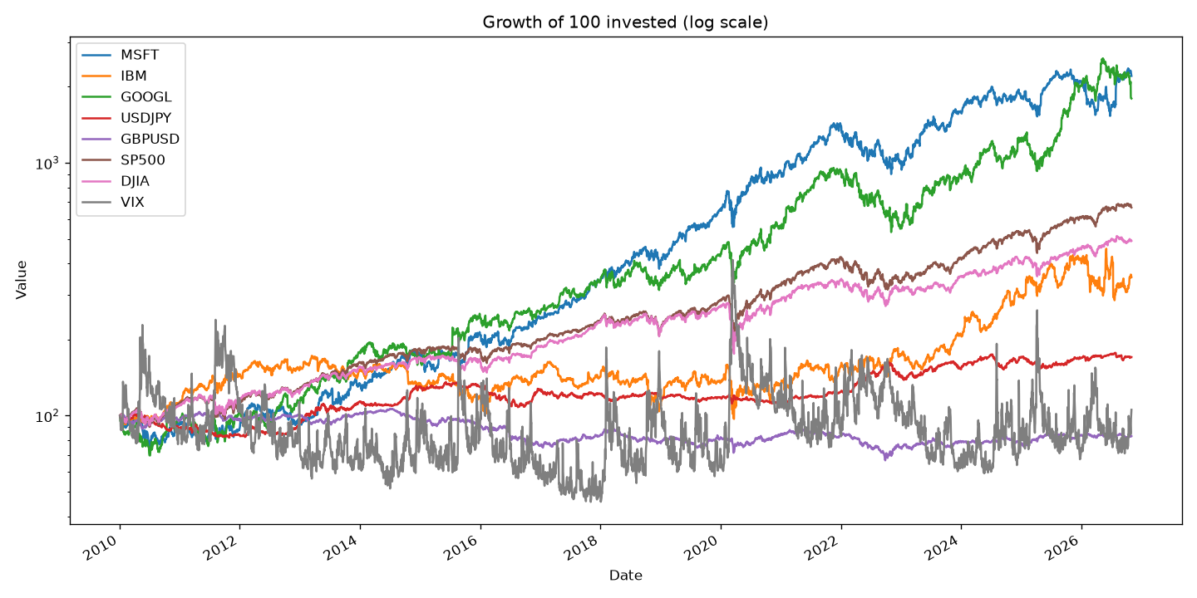
An investment of 100 in MSFT in January 2010 grew to more than 2,000 by November 2026, the strongest of the eight series alongside GOOGL. The S&P 500 and Dow Jones grew more steadily, IBM lagged until 2024, and the currencies stayed within a narrow band. VIX has no trend but spikes during sell-offs: 2011, 2015, 2018, March 2020 and 2025. Because prices trend so strongly, the models use returns rather than price levels.

3.3 Distribution of weekly returns
Series | Mean | Std dev | Min | Max | Skew | Excess kurtosis
MSFT | 0.37% | 3.44% | −15.6% | +22.5% | −0.25 | 4.08
IBM | 0.15% | 3.59% | −34.4% | +16.3% | −1.10 | 12.47
GOOGL | 0.36% | 3.86% | −14.4% | +17.4% | 0.03 | 1.84
USD/JPY | 0.06% | 1.32% | −5.7% | +6.3% | −0.11 | 2.11
GBP/USD | −0.02% | 1.25% | −9.0% | +6.0% | −0.82 | 6.54
S&P 500 | 0.23% | 2.26% | −16.2% | +10.4% | −1.15 | 6.74
Dow Jones | 0.19% | 2.21% | −19.0% | +12.1% | −1.38 | 11.05
VIX | −0.02% | 15.78% | −62.9% | +96.0% | 0.91 | 4.98
All figures are weekly log returns over 846 weeks.
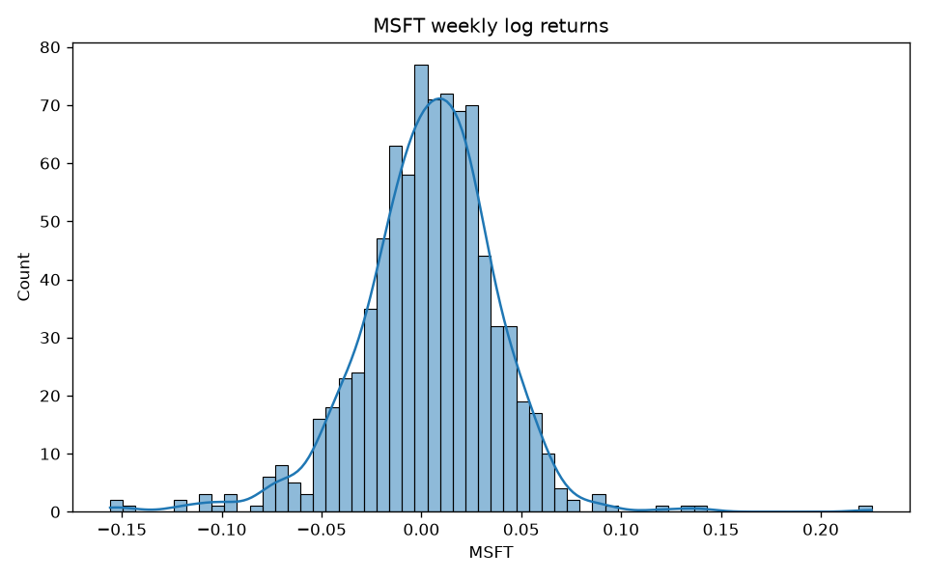
MSFT's weekly return averages +0.37% but varies by 3.44%, so the signal is about one-tenth of the noise. The distribution is bell-shaped but has fat tails: every series has positive excess kurtosis, meaning extreme weeks happen far more often than a normal distribution predicts. MSFT's worst week was −15.6% and its best +22.5%. The stock indices are negatively skewed (large falls are more common than large rises), while VIX is positively skewed because it jumps when markets fall. Fat tails matter for evaluation: a few extreme weeks dominate RMSE, which is why MAE is reported alongside it.

3.4 Correlations between assets
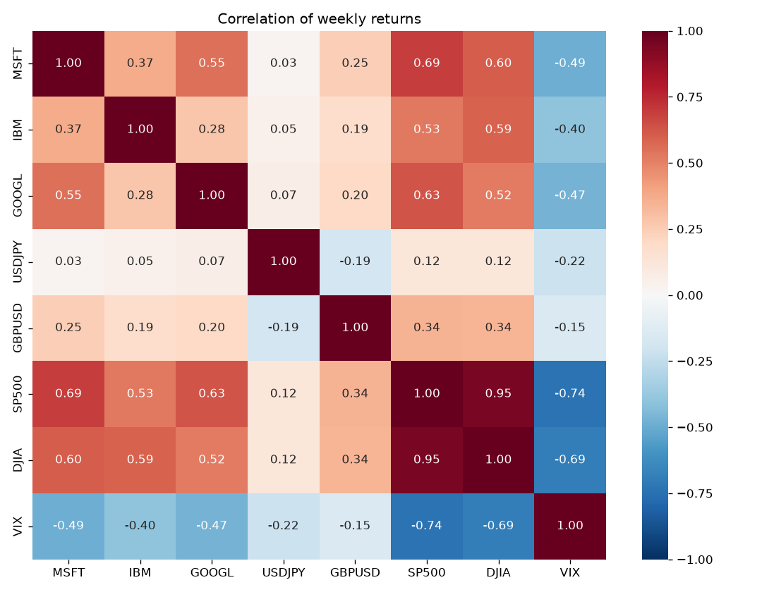
In the same week, MSFT moves most closely with the S&P 500 (0.69), the Dow Jones (0.60) and GOOGL (0.55), and against VIX (−0.49). IBM (0.37) and GBP/USD (0.25) are weaker, and USD/JPY is almost unrelated (0.03). The S&P 500 and Dow Jones are correlated at 0.95, so they carry nearly the same information.
These are same-week correlations. The models must instead predict next week's MSFT return from this week's data, and that relationship is far weaker. The gap between the two is the main reason all five models end up close to the baseline.

3.5 Volatility over time
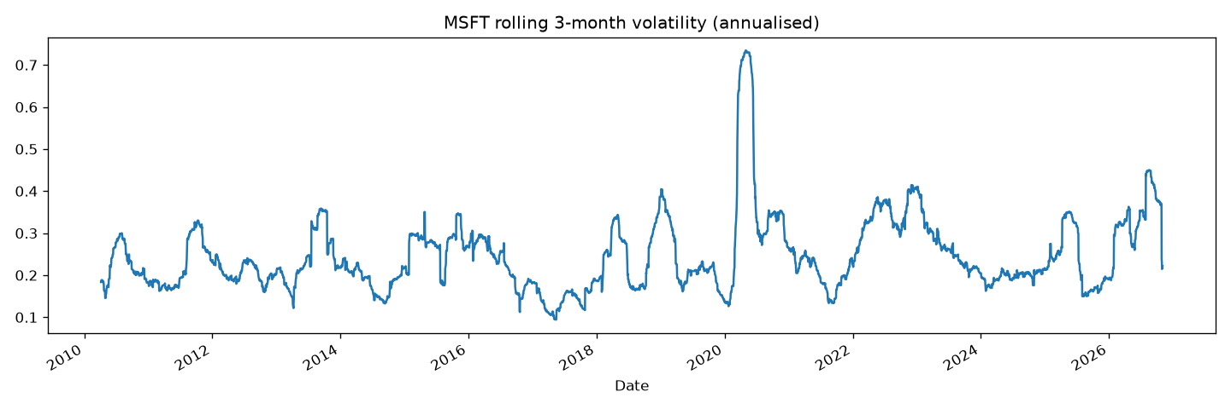
MSFT's annualised volatility usually sits between 15% and 35%, but it jumped to about 73% in March 2020 during the COVID-19 crash, with smaller peaks in late 2018, 2022 and 2026. Volatility comes in clusters, so the test period (mid-2023 to 2026) includes calm stretches and turbulent ones, and a model trained mostly on calm years can be caught out by sudden regime changes.

3.6 Stationarity
The Augmented Dickey-Fuller (ADF) test checks whether a series is stationary, meaning its mean and variance do not drift over time.
Series | ADF p-value | Conclusion
MSFT price | 0.9875 | Non-stationary (p > 0.05)
MSFT weekly return | 0.0000 | Stationary (p < 0.05)
This confirms the modelling choice: a model trained on prices would learn levels that never come back, while returns behave the same way across the whole sample.

4. Results
fastai is the only framework that beats the baseline on every metric; three others match the baseline on RMSE, and TabNet falls below it and changes from run to run.

4.1 Test-set metrics
Model | RMSE | MAE | R² | Directional accuracy | Beats baseline RMSE?
Baseline (mean / "always up") | 0.0374 | 0.0256 | 0 | 56.3% | —
PyTorch + fastai | 0.0367 | 0.0252 | 0.035 | 59.3% | Yes
PyTorch + Lightning Flash | 0.0373 | 0.0262 | 0.006 | 61.7% | Yes, marginally
Keras | 0.0373 | 0.0259 | 0.005 | 61.1% | Yes, marginally
XGBoost | 0.0373 | 0.0257 | 0.003 | 56.3% | Yes, marginally
PyTorch + TabNet | 0.0378 | 0.0267 | −0.023 | 51.5% | No
Test period: 167 weeks, 30 Jun 2023 – 21 Oct 2026. Source: results/comparison.csv.
- fastai lowers RMSE by 1.8% and MAE by 1.5% against the baseline and explains 3.5% of the variance in weekly returns.
- Lightning Flash and Keras have the best directional accuracy (61.7% and 61.1%), about 5 points above "always up", but their MAE is slightly worse than the baseline's.
- XGBoost matches the baseline's directional accuracy exactly (56.3%) because it predicted a positive return in all 167 test weeks. Keras predicted "up" in 92% of weeks.
- TabNet is the only model worse than the baseline on RMSE.
The differences are small. With 167 test weeks, a 1–2% change in RMSE could partly be luck, so the honest reading is that fastai shows a weak signal and the others show little or none.

4.2 Predicted against actual returns
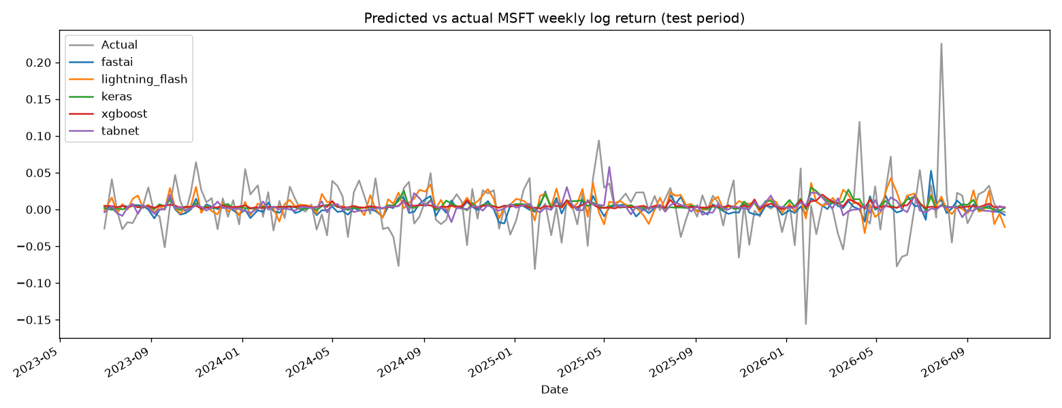
The actual weekly returns (grey) swing between about −15% and +23%, while every model's predictions stay within a few percent of zero. The standard deviation of predictions is 0.3% for XGBoost, 0.6% for Keras, 0.8% for TabNet, 0.9% for fastai and 1.2% for Lightning Flash, against 3.75% for the actual returns. This is what a model should do when the signal is weak: predicting close to the average minimises error, and large predictions would be wrong most of the time.

4.3 Expected return for the coming week
Model | Expected return, week after 2 Nov 2026
XGBoost | +0.49%
PyTorch + Lightning Flash | +0.48%
Keras | +1.04%
PyTorch + fastai | +1.61%
PyTorch + TabNet | +7.14%
Four of the five models expect a small rise of 0.5–1.6%. TabNet's +7.1% is not credible: it is twice the standard deviation of a normal week and comes from a model that failed to beat the baseline. Each figure is a single prediction from one feature row, so it illustrates what the models output rather than forming a reliable forecast. Annualising these weekly figures (for example, 1.6% a week compounds to 129% a year) would exaggerate them further.

4.4 Framework comparison: simplicity, transparency and efficacy
Framework | Simplicity | Transparency | Efficacy | Lines of code | Training time
XGBoost | High | High | Medium | 39 | 17.3 s (60 fits in grid search)
Keras | Medium | Low | Medium | 43 | 1.3 s
PyTorch + fastai | Medium | Low | High | 43 | 2.7 s
PyTorch + TabNet | Medium | Medium | Low | 34 | 12.3 s
PyTorch + Lightning Flash | Low | Low | Medium | 47 | 1.1 s
Lines of code count each model script without blank lines and comments; training times are from the final run on CPU.
Simplicity
- XGBoost was the easiest: one pip install, no feature scaling, sensible defaults and a standard scikit-learn interface. The grid search adds a few lines but no complexity.
- Keras needs the network designed by hand (layers, dropout, optimiser, early stopping) and the inputs scaled. Its default set-up also stalled on the tiny return values until the target was scaled to percent.
- fastai builds the network and data loaders automatically and handles normalisation, but needs its own TabularPandas data format. It printed a progress bar per batch and needed the same target scaling and a callback to keep the best epoch.
- TabNet has the shortest script (34 lines), but it needs scaled inputs, a 2-D target array and attention-specific settings (decision steps, virtual batch size) that are not intuitive.
- Lightning Flash was the hardest. The library is archived and does not install on current Python, so it needed a separate Python 3.10 environment, pinned old versions of PyTorch and PyTorch Lightning, and manual fixes for missing dependencies (setuptools, requests). Its high-level API is short once it runs, but its error messages (such as the early-stopping metric being called valid_loss, not val_loss) took time to work out.
Transparency
XGBoost and TabNet report which features drive their predictions; Keras, fastai and Lightning Flash are black boxes without extra tools such as SHAP.
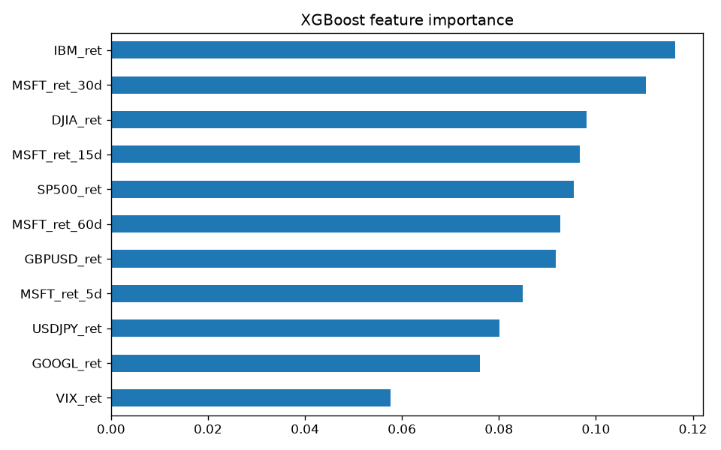
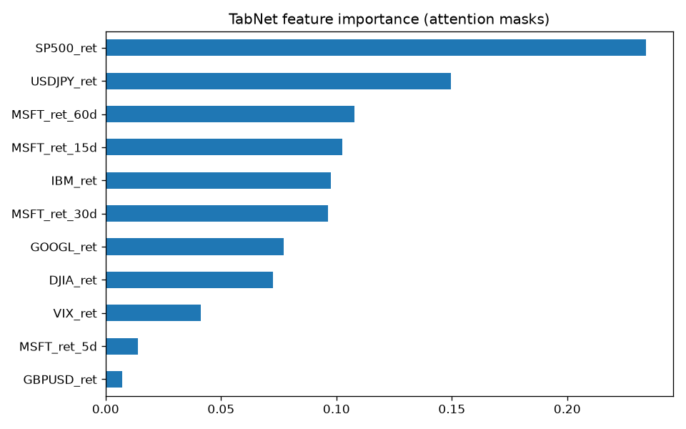
XGBoost spreads importance fairly evenly (0.06–0.12) and ranks IBM's return, MSFT's 30-day return and the Dow Jones highest. TabNet concentrates on the S&P 500 (0.23) and USD/JPY (0.15). The two models disagree, and TabNet's ranking changes when it is retrained, which is a sign that no single feature holds a strong, stable signal. XGBoost's trees can also be inspected directly, which makes it the most transparent of the five.
Efficacy
- fastai was the most accurate model and the only one ahead on every metric.
- Lightning Flash and Keras were the best at calling the direction (61.7% and 61.1%) but did not reduce the average error.
- XGBoost reached the baseline's error but only by predicting a small rise every week, so it added no information.
- TabNet was the least accurate and the least stable. On identical data, its test RMSE was 0.0382, 0.0490 and 0.0378 in three runs, while the other models were stable or close to it. A model whose result depends this much on its random starting point is hard to trust in practice.

5. Conclusion and Summary
Next-week MSFT returns are close to unpredictable from correlated assets and past returns: the best of five frameworks, fastai, beat a naive baseline by under 2% in RMSE.

5.1 Findings
- The data: MSFT's weekly returns are stationary but fat-tailed, and the signal (a +0.37% average) is about a tenth of the noise (3.44% standard deviation). MSFT moves strongly with the market in the same week (0.69 correlation with the S&P 500), but that link barely carries over to the following week.
- The models: fastai was the only model better than the baseline on every metric (RMSE 0.0367 against 0.0374, R² 0.035). Lightning Flash and Keras called the direction correctly in about 61% of weeks against 56% for "always up". XGBoost reduced to predicting a small rise every week, and TabNet was the least accurate and least stable.
- The frameworks: XGBoost was the simplest and most transparent, fastai the most effective, TabNet the most interpretable neural network but the least reliable, and Lightning Flash the hardest to set up because it is no longer maintained.
- The choice: for this problem, XGBoost is the best default for a quick, explainable model, and fastai the best choice when accuracy matters most. Neither gives an edge large enough to trade on once transaction costs are counted.
The results agree with the efficient-market view that past prices and related assets contain little information about next week's price. A small R² is the expected, honest outcome for this task, not a sign of a faulty model.

5.2 Limitations
- Small test set: 167 weeks is too few to tell a 1–2% improvement apart from luck with confidence.
- One split: a single train/test split was used. Walk-forward validation over several periods would show whether results hold across market regimes.
- Run-to-run variation: the neural networks were trained once each with a fixed seed. TabNet showed that results can change on retraining; averaging over several seeds would give fairer comparisons.
- Limited tuning: only XGBoost had a hyperparameter search; the networks used one reasonable set-up each.
- No trading costs: metrics measure prediction error, not profit after costs.
- One feature family: only correlated assets and past returns were used.

5.3 Future work
- Add technical indicators (moving averages, momentum, RSI) and fundamental data (P/E, earnings surprises).
- Add news and sentiment features from headlines or earnings calls.
- Use walk-forward validation and average neural networks over several random seeds.
- Explain the black-box models with SHAP values.
- Try sequence models such as LSTMs that read the return history directly.
- Backtest a simple strategy (hold MSFT when the predicted return is positive) with trading costs, to measure economic rather than statistical value.

References
- Code, notebooks, figures and results: github.com/gopya3106/Stock-return-prediction
- Tatsat, H., Puri, S. and Lookabaugh, B. Machine Learning and Data Science Blueprints for Finance, O'Reilly Media, 2020. Case study 1: stock price prediction.
- Data: Yahoo Finance, accessed with the yfinance Python library.
- Libraries: XGBoost, Keras, PyTorch, fastai, pytorch-tabnet (Arik and Pfister, TabNet: Attentive Interpretable Tabular Learning, 2019), Lightning Flash, scikit-learn, pandas, statsmodels, matplotlib and seaborn.

